Commercial General Liability is a type of insurance typically used for manufacturing but can be used for other business as well.
GL has 5 different possible sublines, which indicate what type of policy it is:
- Commercial General Liability (combines Products Completed and Premises Operations)
- Owners and Contractors Protective Liability
- Product/Completed Operations Liability (excludes Premises Operations)
- Railroad Protective Liability
- Liquor Liability – cannot be written standalone; can only be added to Commercial General Liability
Both the “Owners and Contractors Protective Liability” and “Railroad Protective Liability” provide very specific coverages for these specialized product types.
For GL, the subline changes the product name on the Dec and Quote. The product type is always “Commercial Liability”. All other products do the reverse: the product name stays the same and the “Policy Type” changes to disambiguate between the different kinds of policies.
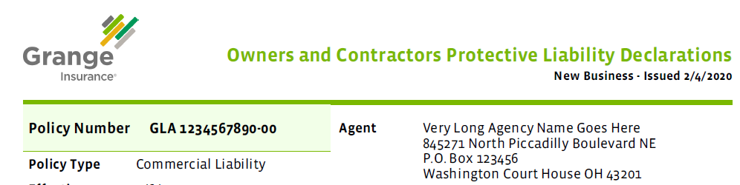
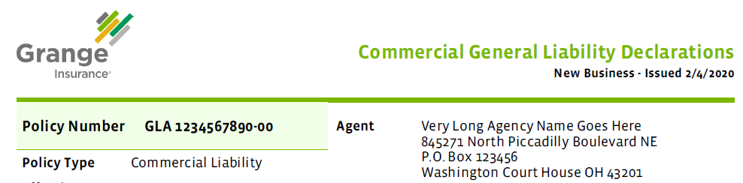
GL does provide a certain amount of coverage by default, although the limits can be chosen to fit the needs of the insured.
Most of the GL coverages are class code based. Class codes represent types of work or products that the business needs to have covered. Each class code has an Exposure/Premium Basis, Per, and Rate associated. All class codes for GL are location based and each location can have a different list of class codes that apply. Rates may vary per location, depending on the state (this is handled by rating – not us.) Each class code may have a different deductible. Some class codes count towards the General Aggregate Limit (meaning that the amount of the loss would be counted towards the total limit available for the Aggregate Limit on the policy, which is one of the coverages included by default.)
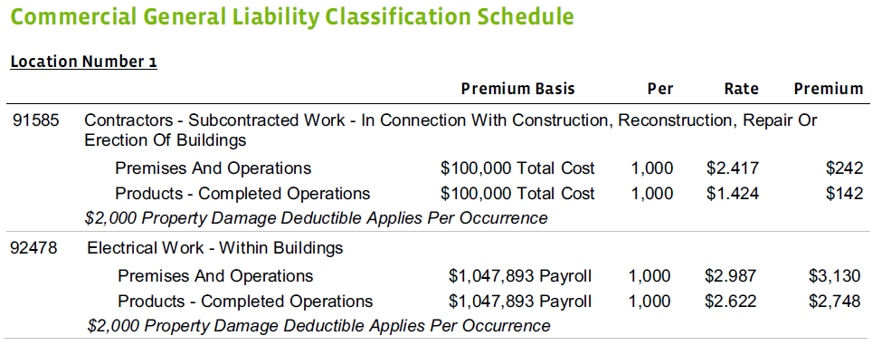
The Premium Basis indicates what is being measured when determining the risk to insure this coverage. In the above example for Class Code 91585, the Premium Basis is “Total Cost”. So the coverage is being evaluated based on the total cost of an item. The “$100,000” is the exposure amount. Although this is not specifically labeled, this is the estimated total cost for “Premises and Operations” for Class Code 91585.
The ”Per” column above has 1,000 in it. Note that this is NOT a dollar amount. This means that per 1,000 of the rating basis (in this case, Total Cost) will be applied towards the premium calculation. If we remember back to our school days, in math class when we saw a word problem with the word “per” in it, that meant we had to divide. So the exposure in the premium basis will be divided by the per amount.
The ”Rate” column indicates what rating factor will be applied in the premium calculation. Very smart people at Grange (and many other companies) spend a lot of time figuring out what this value should be for each class code. I don’t know exactly how they come up with it because I don’t do math.
The “Premium” is the end result of:
(Exposure / Per) * Rate = Premium
($100,000 / 1,000) * 2.417 = $242 (with rounding – and yes I did lots of math for this mockup)
Some GL policy types are subject to a Premium Audit. The audit is used to verify if the exposures provided when the policy was written wound up being accurate. The Exposure number can be just the “best guess” of how much exposure this policy will have for the current term of the policy. This is then referred to as an “Estimated Exposure”. The exposure determined by the audit is the “Audited Exposure”. The premium is then recalculated to determine what the correct premium really should have been for this coverage. The difference is either credited or charged to the customer, depending on the result of the audit.
